Sandy Hook massacre: Harrowing details of Newtown school killings revealed
1. The author has used the term ‘first graders’ – what does he mean? ________________________

2. Why does the author use ‘slaughtered’ and ‘doomed’? ________________________________________________

3. The author uses figurative language to help the reader imagine the scene. What does the author mean by “like sardines”? ________________________________________________________________________

4. Whose gun did he use? What were the guns meant to be used for?
________________________________________________

5. Why has the author used dashes (-) around the phrase “in less than 11 minutes”? What is the effect of writing the sentence in this way? ________________________________________________________________________________________________

6. ‘Lay’ is the past tense of which verb? ____________

7. “who were stacked two or three high” – what does this mean? ________________________________________________

8. “the mother not afraid of her son, but allegedly afraid for him” – what does this mean? ________________________________________________________________________________________________

9. The author does not always use Adam Lanza’s name in the text when writing about him. The author uses other words (not his name) when talking about him in the text. What words does the author use to refer to Adam Lanza?
______________________
________________________
________________________

SOURCE 1
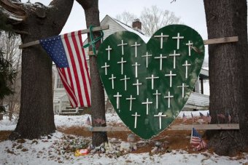
Updated 28 Dec 2013, 3:13pm
PHOTO: Adam Lanza murdered 26 people, including ¹20 first graders, at Sandy Hook Elementary School in December 2012. (Reuters: Carlo Allegri, file photo)
American schoolchildren were ²slaughtered in a hail of bullets after packing ³like sardines into a bathroom in a doomed bid to escape the murderous rampage of Newtown gunman Adam Lanza.
⁴Lanza murdered 20 first graders and six adults at Sandy Hook Elementary School, using a rifle taken from his mother's legally acquired home defence arsenal.
The 20-year-old killer wore yellow ear plugs that muffled the screams of his victims. After committing one of the country's worst school massacres - ⁵in less than 11 minutes - he shot himself in the mouth.
One of the first police officers who arrived at the scene on December 14, 2012 said he discovered a "massive pile up" of corpses in the bathroom of one classroom in the small Connecticut town.
"There appeared to be about 15 bodies in the small room and several bodies, including two adults near the entrance to the room," said the officer, Christopher Vanghele.
An adult victim ⁶lay across the dead children, ⁷who were stacked "two or three high" and packed in "like sardines," probably by the teachers when they heard gunshots.
"As the pile got higher it appeared that there was a mad scramble to get into the bathroom, with people stepping on one another and climbing on top of each other," he said.
There was no longer any space for the teachers to get in, but in the panic they failed to lock the outer classroom door.
The shooter interrupted them and "opened fire on the mass of children and adults... it was clear that no one had survived".
Lanza was dressed almost entirely in black, his clothes - shirts, trousers, boxer shorts, socks, sneakers, fingerless gloves and a belt - stained with blood and gunpowder.
"There was a mad scramble to get into the bathroom, with people stepping on one another” said police officer, Christopher Vanghele.
According to an FBI incident report he ducked into a classroom and turned a weapon on himself after two law enforcement officers arrived, shattering his brain and skull.
According to another witness interviewed by the FBI, Lanza and his mother Nancy owned at least four firearms, which were kept in a gun safe in the school shooter's bedroom closet.
Witness testimony also revealed little known details about Lanza, who suffered from Asperger's Syndrome.
The gunman was a vegan, interested in Japanese techno music and had been taking Chinese lessons. He also knew how to build a computer from scratch by assembling spare parts.
His mother at one point took him out of school because he was sensitive to sound and light and photographs showed various windows taped over with white plastic and black bin liners.
Lanza carried out the murders the morning after his mother Nancy returned from a few days away, which she told one friend had been an "experiment" to allow him to stay home alone.
She told friends she was thinking about moving to the western state of Washington or to North Carolina to enrol her son at a special school or get him a job to make him more self-sufficient.
The investigation was unable to find a motive other than to conclude that the killer was obsessed with mass murders and had "significant mental health issues".
Nancy and Adam Lanza were said to have been close, with ⁸the mother not afraid of her son, but allegedly afraid for him.
Earlier this month, US authorities released recordings of emergency calls made by trapped and terrified people from within the school as the killer stalked the classrooms.

Recent high profile US shootings:
- Sandy Hook: 20 elementary school children, six adult staff members shot dead by gunman Adam Lanza on December 14, 2012.
- Wisconsin Sikh shooting: Six people shot dead, four wounded at a Sikh temple in Wisconsin on August 5, 2012.
- Aurora movie theatre: 12 people shot dead, 58 wounded during a screening of The Dark Knight Rises in Colorado on July 20, 2012.
- Virginia Tech: America's most deadly shooting saw 32 people killed at the university campus on April 16, 2007.
- Columbine High School: Two students shot dead 13 people at the Columbine High School in Littleton, Colorado on April 20, 1999.

Lanza drove to Sandy Hook Elementary having that morning fatally shot his mother in the head as she lay in bed.
On arrival, he killed the school principal and a psychologist in a hallway, then shot dead two adults each in two first-grade classrooms, and shot 15 children dead in one classroom and five dead in the other.
_______________o0o_______________________________o0o_________________________

Sandy Hook shooting: What happened?
SOURCE 2
Twenty-six people -- 20 students and six adults -- were shot and killed at the Sandy Hook Elementary School in Newtown, Connecticut on December 14. Below is a timeline of events.

Before events at the school
10. ‘law enforcement official’ is another word for ____________
11. The ‘loud pops’ refers to ____________________________________________________
12. What happened to the principal and the psychologist? ______________________________________________________________________________
13. What is ‘maternity leave’? ______________________________________________________________________________
14. ‘discharged their weapons’ means what? ______________________________________________________________________________

At some point before he went to the school, investigators believe Adam Lanza, 20, killed his mother, Nancy Lanza.
He grabbed three guns from the house -- a semi-automatic AR-15 assault rifle made by Bushmaster and pistols made by Glock and Sig Sauer -- and went to the elementary school wearing black fatigues and a military vest, according to a ¹⁰law enforcement official.
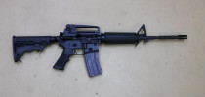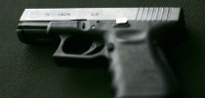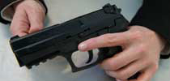
The above weapons are similar to the ones found with the suspect: A Bushmaster rifle, a Glock handgun, and a Sig-Sauer handgun.
Classes were under way at the school. Approximately 700 students were present.
Earlier this year, the school principal, Dawn Lafferty Hochsprung, ordered a new security system installed that required visitors to be visibly identified and buzzed in. As part of the security system, the school locked its doors each day at 9:30 a.m.
The door was locked when the gunman arrived.
Authorities now know the gunman used "an assault weapon" to "literally (shoot) an entrance into the building," Connecticut Gov. Dannel Malloy said.

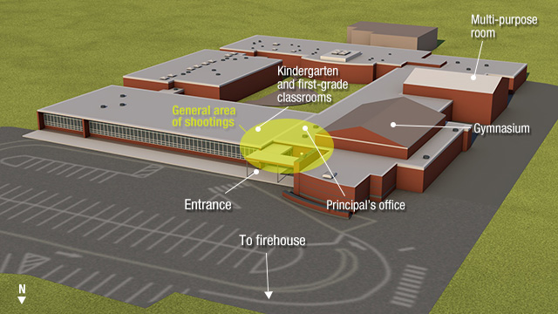
A graphic depicting the site of the shooting. (CNN)

Inside the school
Hochsprung heard ¹¹loud pops. She, school psychologist Mary Sherlach and vice principal Natalie Hammond went out to investigate.
¹²Only Hammond returned from the hallway alive. She was wounded.
At about 9:30 a.m., as announcements were read over the loudspeaker to the students, shots were heard across the school. Students described being ushered into bathrooms and closets by teachers after hearing the first shots.
Lanza moved toward two classrooms of kindergarteners and first-graders, police said.
In one classroom was Lauren Rousseau, a substitute teacher who was filling in for a teacher out on ¹³maternity leave. The gunman shot all 14 students in the classroom, law enforcement officers said.
In another classroom, Victoria Soto, 27, moved her first-grade students away from the door. The gunman burst in and shot her, according to the father of a surviving student. Six students were killed in that classroom.

First responders arrive
At the police station, dispatchers began to take calls from inside the school. Authorities say the first emergency call about the shooting came in at "approximately" 9:30 a.m.
"Sandy Hook school. Caller is indicating she thinks someone is shooting in the building," a dispatcher told fire and medical personnel, according to 911 tapes.
The first officer arrived on the scene of the Sandy Hook school shooting two minutes and 41 seconds after the first police radio broadcast of the shooting.
Police report that no law enforcement officers ¹⁴discharged their weapons at any point.
The gunman took his own life. He took out a handgun and shot himself in a classroom as law enforcement officers approached..
Twenty students, ages 6 and 7, and six adults were killed at the school.
Police secured the building, ensuring no other shooters were on site. Police then escorted students and faculty out of the building to a nearby firehouse.
As reports of the shooting emerged, frantic parents descended on the firehouse where the children had been taken.
By nightfall, the firehouse became a gathering point for parents and family members whose loved ones would never walk out of the school.
___________o0o__________________________o0o____________________o0o____________o0o__________________
- Match the person to the description:
DESCRIPTION | ANSWER |  | PERSON
- Sandy Hook Principal |  |  | - Nancy Lanza  - Lauren Rousseau  - Victoria Soto  - Dannel Malloy  - Adam Lanza  - Dawn Lafferty Hochsprung  - Mary Sherlach  - Christopher Vanghele  - Natalie Hammond
- The killer
- Sandy Hook psychologist
- policeman
- the killer’s mother
- Sandy Hook first grade teacher
- Sandy Hook substitute teacher
- Sandy Hook deputy principal
- Connecticut Governor

- MATCH THE WORDS WITH THE MEANINGS:

a. another word for staff
b. another word for cupboard
c. making sure or secure
d. from the beginning, from the most basic
e. a person who eats only plant products, no animal products
f. workers
g. able to be independent, to look after themselves
h. reason
i. dead bodies
j. killed in a cruel way
k. a person whose job is to receive messages and organize the movement of people or vehicles, especially in the emergency services.
l. putting together
m. almost out of control because of extreme emotion, such as worry
n. special clothing worn by military personnel to carry out fighting
o. led, guided
p. smashing or breaking into pieces
q. a formal written or spoken statement, especially one given in a court of law.
r. Certain to suffer death, failure, or a similarly negative outcome
s. to deaden (sound) by wrappings or other means

t. a disorganized struggle; a quick and disorganised rush
u. resulting in death
v. very distressing or painful
w. effort or attempt to achieve
x. reportedly; supposedly; not proved
y. a collection of weapons
z. a period of violent and uncontrollable behaviour
aa. moved quickly to avoid something

FRANTIC | ENSURING | PERSONNEL | DISPATCHERS | USHERED
CLOSET | FATIGUES | FATALLY | ALLEGEDLY | HARROWING
SLAUGHTERED | DOOMED | BID | RAMPAGE | ARSENAL
MUFFLED | CORPSES | SCRAMBLE | DUCKED | SHATTERING
TESTIMONY | VEGAN | FROM SCRATCH | ASSEMBLING | MOTIVE
SELF-SUFFICIENT | FACULTY

